Noah Smith

CIS 310

9/29/19

Homework Week 6

Page 157. #8

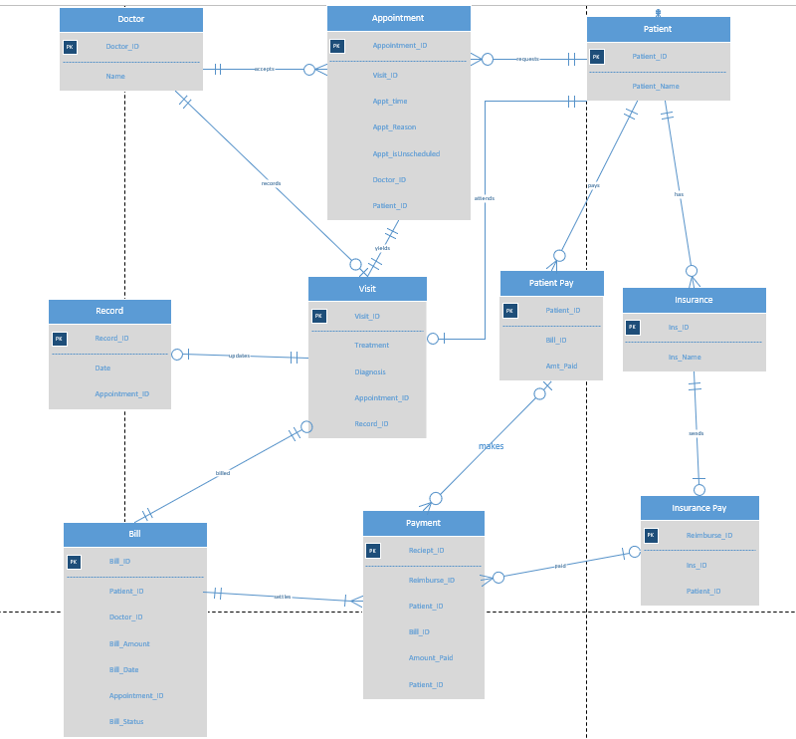

Video Summary:

Autonomous Data Warehouse is a new type of cloud data management. Oracle thought about how databases are currently managed and what they can do to make them self-managing, preparing, and on the cloud. They wanted the fasted performance and elasticity. When you log into Oracles cloud you give a database name, how many CPU’s, the number or TB, and the admin password. You do not have to specify the type of storage or memory that you are using, the database makes optimal decisions based on how your data is being used. The presenter used the analogy of autonomous cars, you tell them where to go and they go.

Oracle has spent decades working to make things as simple and automated as possible. They automate end-to-end management of the data warehouse; the users don’t have to worry about patches and updates. The online service console can be used to see the scripting. They also have automated tuning, as they call it, “load and go” you can load their data and instantly load/run queries. There are automatic backups that can be recovered at any time in the last 60 days. Their disks are also triple mirrored.

There is instant elasticity, you only pay for exactly what you use. You aren’t choosing a specific number of nodes, the warehouse is scaled based on what you are using, if you want to manually scale up or down you can do that as well. The architecture of an autonomous data warehouse contains many other parts. There needs to be data integration, 3rd party BI, and analytics. Also, if a business uses their own tools then they can run those of their server as well.

If you are already on Oracle, you can easily migrate to the new system. All of the schema will be adjusted accordingly, there is a migration workbench that can be used as well. There are many benefits including speed, service, and costs. There are also faster implementations, new queries can be added faster. All of oracles best practices have been added together in order to create the best data system there is. They are designed for analytics; it is a great system to get started in oracles cloud. This represent a whole new chapter in the data management world.